Annual Kharif Oilseeds Group Meet [AICRP on Oilseeds (Castor & Sunflower) and AICRP on Sesame & Niger, 2023] held at Agriculture University, Mandor, Jodhpur during June 1-2, 2023.
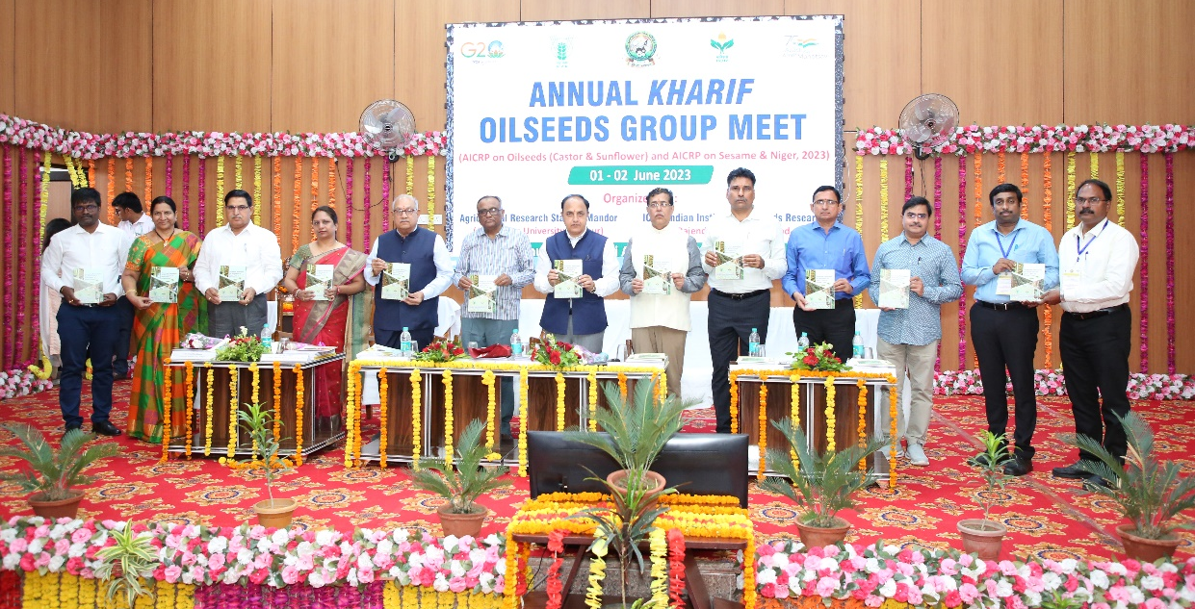

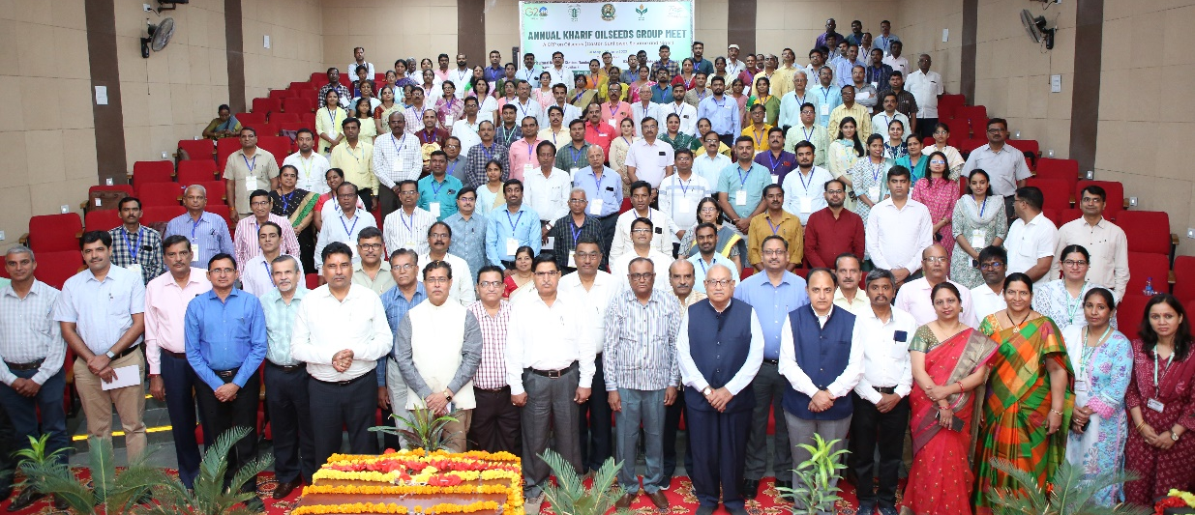

At the outset, Dr. S.D. Ratnoo, Director of Research, Agricultural University, Jodhpur expressed the gratitude to the dignitaries in his welcome address. Dr. Sanjeev Gupta, ADG (Pulses and Oilseeds), ICAR, New Delhi congratulated the group for increasing the production by 3 m.t. with a record production of 41 m.t. of nine oilseed crops during the current year (2002-23). This gain in oilseed production was mostly from soybean (2 m.t.), rapeseed mustard and groundnut (1 m.t.). Though the contribution of sunflower, sesame and niger is very meager with 1/10th of area and 1/7th of total edible oilseed in edible oilseed kitty, nevertheless these group of edible oilseed crops have a significant role in Indian oil economy. Dr. Sanjeev Gupta further emphasizing the importance of castor as a non-edible oilseed crop, two significant achievements viz., incorporation of wilt resistance in high yielding background and two line heterosis system in hybrid breeding program contributed to the success of castor hybrids in India. Biotic stresses like gray mold in rainfed areas, capsule borer and whiteflies are the major challenges in addition to development of high yielding hybrids with a potential of >6 t/ha to compete with other remunerative competing crops. Sesame, the queen of oilseed crops, is still to be exploited for its potential as confectionary and export up to 3000 t with minimum pesticide residues. Focused research on increasing the productivity per se, confectionary types with higher oil content, resistance to biotic stresses like blight, root rot and phyllody and identification of bio-pesticides is the need of the hour. Dr. Sanjeev Gupta further mentioned about the sunflower revival scheme where in ICAR-IIOR will lead the work along with other stakeholders viz., Karnataka Oilseeds Federation (KOF) and ICRISAT through integrated approaches.
Dr. R.K Mathur, Director, ICAR-IIOR, Hyderabad presented the research highlights of AICRP on Oilseeds (castor and sunflower) covering mandate, area, production, productivity dynamics, plant genetic resources, number of hybrids/varieties in MLTs released and highlights of breeding, crop production, crop protection, FLDs and new initiatives of research. He emphasized the need to double the present productivity to compete with other remunerative short duration crops. He also suggested breeders to breed varieties for machine harvesting and exploit heterosis using combination of good and poor combiners for seed yield. Dr. Rajni Bisen, Project Coordinator, AICRP on Sesame & Niger, Jabalpur presented the research highlights of breeding, crop production, FLDs and crop protection in sesame and niger crops.
The dignitaries also released few publications on the occasion of Annual Group Meeting of Castor, Sunflower, Sesame and Niger with a special emphasis on best management practices of castor (in hindi), mechanization in castor, screening techniques for resistance to insect pests in oilseed crops and edible oils, etc. Best performing centres in each crop of castor (S.K. Nagar, Junagadh, Yethapur), sunflower (Bengaluru, Raichur, Latur), sesame (Vridhachalam, Amreli, Mandor) and niger (Chhindwara, Vanarasi) were awarded based on the recommendations of QRT Review meetings on oilseed crops.
The guest of honor, Dr. A.R. Pathak, Former Vice Chancellor, JAU Junagadh & NAU, Navsari expressed his concern for area reduction in all oilseed crops. Among the several reasons for non-adoption of technologies, identification of lacunae and fine tuning the technologies is the best solution. Area expansion in oilseed crops has a limited scope while cropping systems research is important for these niche crops. Climate resilient crops like niger need attention for development of season specific varieties. Selection of parents in crossing programme is very important while exchange of crosses and segregating material to different centres will also hasten the process. Intensified efforts on restructuring plant architecture and drip fertigation are essential. Strategies to increase area in all oilseed crops is to be thoroughly discussed.
The Chairman, Dr. T.R. Sharma, DDG (Crop sciences), ICAR, New Delhi expressed his concern about the expenditure of Rs.1,75,000 rupees on import of edible oilseeds. Area expansion strategy is relevant based on remunerative income of oilseeds over competing crops. The Chairman further emphasized the issues of research to be focused in castor like gray mold resistance especially under rainfed areas, yield enhancement up to 6 t/ha under irrigated conditions of Gujarat, marker assisted selection for traits like resistance to wilt, gray mold, pests, etc., ideal plant type for high density, mechanical, multiple parent crosses etc. Productivity in sesame need to be enhanced to >1.5 t/ha with a greater utilization of germplasm, secondary gene pool and wild species for determinate, photo and thermos insensitive plant types coupled with resistance to phyllody. Organic sesame cultivation is also gaining importance along with management of storage pests. In sunflower, pre-breeding along with sharing of segregating material has given good results. He also stressed the importance of partnership between public vs private sector. Emphasis on high oleic lines with focused breeding strategies like double haploid, speed breeding, MAS, genomic resources for conversion of lines to CMS and restorer and host plant resistance to major pests and diseases is the need of the hour. In Niger, development of high yielding varieties, synthetics, composites and innovative approaches for management of cuscuta are suggested. Product profiling of oilseed crops with yield as target trait, resistance to major pests and diseases, water and nutrient use efficiency, short duration, high oleic are the key issues. Plant genetic resources need to be thoroughly exploited following standard screening procedures for major pests and diseases. Special fund is provided to Indian Institute of Oilseeds Research to carry out genome editing and the end products need to be evaluated in the AICRP system.
The Chief Guest, Dr. B.R. Chaudhary, Vice Chancellor, Agricultural University, Jodhpur in his concluding remarks of the inaugural session, emphasized the vital role of oilseeds in food security and generation of employment. Farmers and researchers have to be complimented for increasing the production of oilseed by 2 m.t. up to 40 m.t. India is the largest importer of edible oils due to increase in population size, per capita consumption of oils leading to a gap of 25% between demand and supply. Among the oilseeds, soybean, rapeseed & mustard and groundnut occupy 95% of oilseeds economy. Among the states, Rajasthan, Maharashtra, Madhya Pradesh and Gujarat with 75% of oilseeds production are the major states. Rajasthan has sizable area under Castor and Sesame up to 2 lakh ha. Non-shattering sesame and castor hybrids resistant or tolerant to frost need to be addressed.
The Varietal Identification Committee (VIC) meeting under the Chairmanship of Dr. T.R. Sharma, DDG (Crop sciences), ICAR, New Delhi was held on June 1, 2023, through Hybrid Mode during June 1 to 2, 2023 at Agricultural University, Mandor, Jodhpur, Rajasthan. Seven proposals such as two from sunflower [IIOSH-460 (TilhanTec-SUNH-2) and KBSH-88], one from castor [TilhanTec ICH-6 (ICH-1146)], three from sesame [TilhanTec Til-1 (IIOS-1101), Sabour Til-1(BRT-04) and CUMS-09A (Tanjila)] and one from niger (JNS 2017-13). Dr. R.K. Mathur, Director, ICAR-IIOR, Hyderabad has presented the castor (1) & sunflower (2) proposals. Dr. Rajani Bisen, I/c PC Unit, AICRP on Sesame & Niger, Jabalpur has presented the sesame (3) & niger (1) proposals. All the seven proposals were identified.
Dr. B.R. Chaudhary, Vice Chancellor, Agricultural University, Jodhpur; Dr. T.R. Sharma, DDG (Crop sciences), ICAR, New Delhi; Dr. Sanjeev Gupta, ADG (Pulses and Oilseeds), ICAR, New Delhi; Dr. A. Vishnuvardhan Reddy, Vice-Chancellor, Guntur, Andhra Pradesh; Dr. A.R. Pathak, Former Vice Chancellor, JAU Junagadh & NAU, Navsari; Dr. S.R. Maloo, Dean & Chairman Faculty of Agri Sciences, Pacific College of Agriculture, Pacific University, Udiapur, Rajasthan; Dr. A.S. Panwar, Former Director, ICAR-Indian Institute of Farming Systems Research, Modipuram, Meerut, UP; Dr. D.M. Hegde, Former Director, ICAR-IIOR, Hyderabad; Dr. R.K Mathur, Director, ICAR-IIOR, Hyderabad were planted Palm Tree in front of New Office Building at Agricultural University, Jodhpur on June 2, 2023.
The Plenary Session was chaired by Dr. A.R. Pathak, Former Vice Chancellor, JAU Junagadh & NAU, Navsari. The session was Co-Chaired by Dr. Sanjeev Gupta, ADG (O & P) and the Guest of Honor was Dr. A. Vishnuvardhan Reddy, VC, ANGRAU, Guntur, Andhra Pradesh. The meeting started with a welcome address by Dr. R.K. Mathur, Director, ICAR-IIOR, Hyderabad. During the session, highlights of technical sessions pertaining to various disciplines of sunflower, castor, sesame and niger were presented by PIs/Co-PIs of each discipline. The following major recommendations emerged during the course of deliberations.

Recommendations
- All technologies developed and validated under different disciplines since inception of the AICRP should be brought out as a technical compendium.
- National Genetic Stock Screening Nurseries (NGSSN) for all important diseases and pests should be taken up at hot spot locations under optimum pathogen and pest load at least for three years and validated.
- Efforts should be intensified to have better understanding of host-pathogen-vector relationships of SND in sunflower for evolving practicable management strategies.
- Nematode infestation in castor crop in Saurashtra region of Gujarat state need to be addressed in collaboration with AICRP-Nematodes.
- Geo-tagging and geo-coordinates need to be emphasised in FLDs.
- In the absence of label claims of pesticides being used in the oilseed crops, fungicide/pesticide residue and the effect of these molecules on germination and growth of succeeding crops need to be recorded. Effect of the insecticidal spray on natural enemies also need to be recorded.
- Bio intensive integrated pests management modules need to be formulated to address the pesticide residue for major pests.
- In sesame, export oriented traits need to be addressed in addition to identification of few traits to fit in to different cropping systems/seasons.
- Brainstorming session on sesame phyllody need to be organized by ICAR-IIOR preferably at RARS, Tirupathi ANGRAU and the programme being developed at ICAR-IIOR to address phyllody may also be deliberated.
- Mapping of area for sesame and niger expansion should be taken up.

The session ended with vote of thanks by Dr. M. Sujatha, Principal Scientist and Head, Crop Improvement, ICAR-IIOR, Hyderabad.

